AX-CPT Comprehensive Protocol

AX-CPT Task Information:
What is AX-CPT?
AX-CPT (Cohen et al. 1999) is a task used to measure cognitive control, specifically inhibitory control (Zirnstein, M. et al., 2018). AX-CPT is the AX-Continuous Performance Task, a version of the CPT modified to be used under conditions where task goal maintenance is required over a delay period, whereby it can test reactive inhibition control and proactive goal maintenance. AX-CPT can be used as a regressor (individual differences), and used as a data point for subjects regarding their cognitive abilities. AX-CPT has been found to be sensitive to healthy aging and bilingual experience-related control ability changes.
The task takes around 10-15 minutes for participants to complete. Participants are presented with a series of trials, instructed to make a response to distinguish between stimuli. Example: press ‘M’ (Yes) if the target (X) was proceeded by an ‘A’, or ‘Z’ (No) if the target/probe letters are not preceded by an ‘A’.
The task has two parts:
- Practice trials (training for the participant)
- Experimental trials
AX-CPT is a context processing and goal maintenance task that measures reaction time (RT) and accuracy (ACC), and is used in behavioral and neuroimaging studies. (add citations)

Requires: E-Prime 2 and/or 3; access to edat files

Notes (If using PIRE 2 Laptop):
Make sure your computer is migrated to EAD (laptop has been moved from local server onto the PSU domain). You will use your PSU email to log in to the laptop, rather than using the laptop’s local account information.
Accessing E-Prime does require usage of Global Protect (VPN)
If unable to download E-Prime, consider usage of VM Horizons (virtual desktop environment) to remote in access, contact IT for assistance.

How to Open and export the edat files using E-Prime E-Merge software

- Save the needed edat files from E-Prime into a folder on your computer (Note, the files must be in edat format to be merged in E-Merge)
- Open E-Prime’s E-Merge software
- In the folder tree view, find the folder that contains the edat files you want to merge.
- After selecting the appropriate folder, select all of the files you want to merge. Do this by clicking on the first file, holding down the SHIFT key, and using the DOWN ARROW to select all files as wanted.
- Follow the directions to complete a standard merge of the files you selected.
- Choose file type for the merged file will automatically be an .edat2 file
- Finish steps to Merge all AX-CPT edat files
- Now all participants’ data should be in one file

Using E-DataAid to convert the edat file to a .txt file

- Open the merged file in E-DataAid, the data should appear to be in a table format.
- Go into the E-Prime script
- View the trials (where each trial is viewed as a line)
- You can now use menu options to export it as a .csv or .txt file. To access the file in Excel, you must save it as a .txt file.
- To do this, click File -> Export -> Export to: Excel
- The single merged file can now be opened in Excel and R.
- Open the appropriate application and open the .txt file within the application.

Processing

- Open .txt file in Excel, remove first row, save as .csv file
- Run AXCPT Coding R Script

Scoring
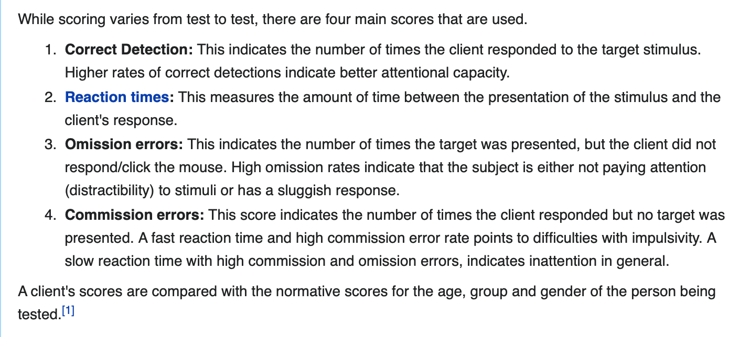

Conditions: Understand that each line in the spreadsheet is a trial, so be aware of how many trials overall and be aware of how many trials per condition (including AX, AY, BX, BY conditions).
Description of conditions: These conditions are testing and measuring the following:
Output Variables: R can be used to explore your output variables.
(list what they are, what they represent, and discuss in general the variables bc they repeat for each condition.)

Other Notes:
E-Recovery is a separate software to recover or convert .txt files to edat files.
E-DataAid is a software that allows you to look at data in a spreadsheet.

Troubleshooting:
Cannot open files/not showing in EPrime-3.0 ?
-Must use appropriate E-Prime software, 2 vs. 3 based on your file type, or contact IT with further difficulties.
-You can use the Software application in your windows computer, to download E-Prime 2.0 or 3.0 through Penn State if your equipment does not already have E-Prime.

MY NOTES:
Looking at R script (box : Daisy Process Attempt -> Scoring Instructions Daisy used -> AXCPT Coding PIRE.R file.. open in R and R Studio, look over the script itself and output)
Add screenshots
Daisy’s note- For the variables in R script output, can you document the- generally speaking since the variables repeat for each condition. Here I am referring to the output variables in the 'Matrix' file, for example the 'WL_AX-CPT Matrix' csv file.

I'm not sure if I mentioned this previously so I'll bring it up just in case. The number of trials for each condition can be found in the E-Prime file where the experiment script is created (not the E-run).

When describing the interpretation of the results, it would be nice to include averages or typical ranges of the performances or describe what a high or low performing individual will score for the various conditions (if this information is available in one of the reference papers or a recently published article using AX-CPT).

References
Zirnstein, M., Van Hell, J. G., & Kroll, J. F. (2018). Cognitive control ability mediates prediction costs in monolinguals and bilinguals. Cognition, 176, 87-106. doi:10.1016/j.cognition.2018.03.001
Cohen, J.D., Barch, D.M., Carter, C.S., & Servan-Schreiber, D. (1999). Schizophrenic deficits in the processing of context: Converging evidence from three theoretically motivated cognitive tasks. Journal of Abnormal Psychology, 108, 120-133.

